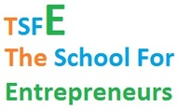

[***http://twitter.com/tsfe.in***](http://twitter.com/tsfe.in)

[***http://facebook.com/tsfe.in***](http://facebook.com/tsfe.in)

[***admissions@tsfe.in***](mailto:admissions@tsfe.in)

***TSFE - The School For Entrepreneurs***

**ONLY FOR THE FIRE IN THE BELLY and THE DREAM IN THE EYES**

[**1st. APRIL 2022 - RELaunch of: TSFE - ONLINE**](http://www.tsfe.in/tsfe-online.html)

[**CLICK THE LINK BELOW to pay for the 40 HRS tsfe ONLINE PROGRAM**](http://www.tsfe.in/tsfe-online.html)

**[](https://www.payumoney.com/paybypayumoney/#/40A99F738ECB6E8FDE7175B97A4014BF)**

*Path of Entrepreneurship is a path of love, which however many times you get jilted you cannot give up as it is an intrinsic need for the ones who have once tread the path. Just like you have fallen in love once, and you cannot stop seeking love and you carry on until you get it. And as we know love keeps you satiated for a while, and then you seek for new love, maybe in the same relationship or in a new one. For a chemically brain driven entrepreneur it is mostly the same. He/she either finds out new ways of doing things within his or her enterprise, by exploring and expanding, or seek new opportunities and new adventures in creating new ventures, new enterprises. The driving force behind a true real entrepreneur, the chemically driving substance institutionalized in ones brain is the continuously dynamic super-active DNA of Creativity, of creating something new, something which challenges one more than the last one. An entrepreneur aspires to feel like a God in ones pursuit of creativity and creation. The God Feeling (without really realizing for oneself) is the ultimate self realization of an entrepreneur, his/her Moksha, Moksha in creation and creativity.*

​***​*TSFE**'s unique program for 2 years discovers and develops**THE RIGHT ASPIRANT** with **THE FIRE IN THE BELLY** and **THE DREAM IN THE EYES**, chosen through a gruelling selection process to become an entrepreneur at the end of the 2nd year running an enterprise which is built with the foundation of a scalable enterprise, which can in due course be funded by both financial institutions and/or Angel or VC Funding with the running companies kick starting POC or next stage. The proof of the pie is in the pudding, so unless we do not get TSFE-ites to be be kick starting on their startups which can possible scale to a certain level and for that it's foundation is built, we do not believe we have delivered. Our Select Faculty Mentors are either high level intrapreneurs or entrepreneurs who are on their hard path of success and growth, and many serially failed and successful entrepreneurs who knows best the path of entrepreneurship.  
Undergraduates and Postgraduates in any discipline who wants to pursue the path of becoming an entrepreneur, be their own boss, have the opportunity to earn in crores, should positively explore TSFE - The School For Entrepreneurs' 2 year elite program which promises to deliver to you the following, if you have the hard capability to walk in full stride with us and have real fire in the belly:

* A running scalable and sustainable company at the end of 2 years
* Initial Traction of revenue of up to Rs 10 lakhs at the end of the program
* Sure Funding by Financial Institutions of up to Rs 1 crore
* A certificate for successful program completion in Partnership with Indian Institute of Corporate Affairs, Ministry of Corporate Affairs, Govt. Of India
* In case a student is not keen to pursue a career in Entrepreneurship, with the experience gained through this program, a sure shot opportunity to be placed in a good company as an intrapreneur manager
* This program is run by the best resources pulled from the Entrepreneurship World in India who are either established Entrepreneurs or top intrapreneur managers from leading companies in the country

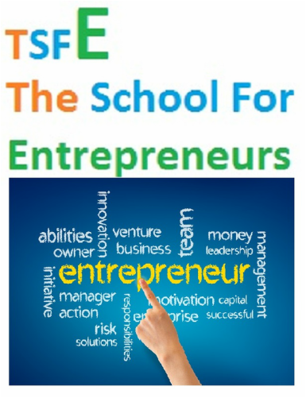

* *The Program*
* The Program which ensures that you are an entrepreneur at the end of the program

[**FOR MORE**](http://www.tsfe.in/program.html)

[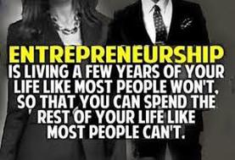](http://www.tsfe.in/uploads/1/7/3/3/17335985/7324933_orig.jpg)

*The Faculty*

* The Faculty which engages with you as mentors who are themselves senior intrapreneurs or entrepreneurs - succesful or on path of success

[**CHECK THEM OUT**](http://www.totalstart.org/mentor-board/governance-board/)



*Your Admission*

* ﻿The Admission process ensures that only the ones who has the guts takes on this unbeaten path of glory

[**APPLY ONLINE**](https://docs.google.com/forms/d/15jGSXBAVaQlMwEFHd9ZqJwwBQISo-1p-tf4ujdkP5UM/viewform)

***Who We Are***

|  |
| --- |
| *TSFE - The School For Entrepreneurs**is the creation of TotalStart Entrepreneurship Ecosystem Developers a India based Section 25 not for profit organization focused on the mission of spreading entrepreneurship in underdeveloped regions and underprivileged communities* |

*TotalStart builds entrepreneurial ecosystems to sustainably nurture and develop home grown entrepreneurs and enterprises in entrepreneurially less developed regions in the world, networked with resources from entrepreneurially developed regions in the world. in domain specific business areas relevant for the region.*  
Conceptualized and created in 2002 at the StarterZentrum of the University of Saarland, Saarbruecken, Germany. Present Strength of 200+ Direct/Indirect or Co-Founding FTEs in its incubated, co-incubated, co-created and mentored companies.  
TotalStart endeavors to promote, aid, encourage, develop, protect and secure the interests of the start-ups by providing education, training, guidance, mentoring, learning, research, marketing, advisory services including legal, administrative, financial and connects to industry associations, business leaders, relevant corporate entities, government organization & financing agencies to incubatees/mentees and to provide and procure requisite physical / IT / administrative / financial / legal / HR / sales & marketing infrastructure for the same.

* 2002 – Total Infosystems GmbH was incubated in StarterZentrum, University of Saarland, Germany
* 2002-2005 – Serial Investments in BPOZen (closed down), DigitalFuel (exit), EZLegacy (part exit)
* 2006 – Incubation of TotalinX India
* 2007 – Incubation of TotalPub (co-founding sustainable salaried employee with shareholding up to 50%  concept) (paused)
* 2008 – Investment in EZSource (on going till date)
* 2009- Incubation in TotalPress (co-founding sustainable salaried employee with shareholding up to 50%  concept) (on going)
* 2010 – Creation of TotalStart – A Startup Initiative of TotalinX to focus in Indian remote regions
* 2012 – Kickstarting the TotalStart Sikkim Innovation & Incubation Center at STPI Gangtok; Mentoring District Level Entrepreneurs with Sikkim Industry Department & IT Department
* 2012 – Adopting one of the first incubatee mentee Nalanda Learning Systems Pvt. Ltd. as an  impact enterprise
* 2013 – Incubating TotalAnima (an animation & game development company in Sikkim)
* 2013 – Setting up TotalStart Bengal Innovation & Incubation Center, Exploring Meghalaya & Bhutan for incubation. Kickstarting District Level Mentoring and discovering gems of Bengal
* 2014 – Legally forming TotalStart Entrepreneurship Ecosystem Developers as a section 25 company; Fanning out activities to Durgapur, Siliguri as incubators and exploring in Tripura, Jharkhand & Bihar
* 2015 – Launching TotalStart Sikkim & Bengal District Innovation & Incubation Units
* 2002-2005 – Mentored 10 startupreneurs and incubated 3 start-ups
* 2006-2010 – Incubated 4 start-ups and mentored 30 startupreneurs
* 2011-2013 – Incubated 3 start-ups and mentored 17 startupreneurs officially
* 2014-till date – Incubating 3 start-ups and mentored/(still mentoring some) 170 startupreneurs officially  
  for periods of 1 month to 12 months or more

## *****TOTALSTART******– OUR INITIATIVES AND PROGRAMS* [*****TotalCube*****](http://www.totalstart.in/totalstart---totalcube.html)*****:******Setting up and running a chain of Innovation Incubation Centers [TotalGovCube](http://www.totalstart.in/totalstart---totalcube.html): Setting up and running Innovation Incubation Centers in PPP model with State and National Governments ​******[TotalInCube](http://www.totalstart.in/totalstart---totalcube.html):******Setting up and running an Innovation Incubation Centers in ppp model with Educational Institutes* [*****TotalMentor*****](http://www.totalstart.in/totalstart---totalmentor.html)*****:******Providing Start-up Mentoring and Support to companies who are not part of any of the Innovation Incubation Centers – Extended Mentor-ship Program* [*TotalIntern*](http://www.totalstart.in/totalstart-ndash-totalintern.html)*: Entrepreneurship Internship Program for Pre-final & Final Year Students carrying out MBA/MTech/BTech in premier institutions at TotalCubes/TotalInCubes* [*TotalInclude*](http://www.totalstart.in/totalstart---totalinclude.html)*****:******Social Entrepreneurship Incubators – our social entrepreneurship start-up Ecosystem******[TotalCluster](http://www.totalstart.in/totalstart-ndash-totalcluster.html)******: Product Innovation Clusters  – Strategic Tie-ups with Global Product SMEs to co-create IPs and Applied Innovation Products  and provide global delivery model based services for these SMEs******[TotalWomentrepreneur](http://www.totalstart.in/totalstart---totalmentor.html):******Providing Startup Mentoring and Support to women who are not part of any of the Innovation Incubation Centers – Extended Mentorship Program* [*****TotalStudentrepreneur*****](http://www.totalstart.in/totalstart---totalmentor.html)*: Providing Startup Mentoring and Support to students who are not part of any of the Innovation Incubation Centers – Extended Mentorship Program but engaged in Institutes of Higher Learning*

|  |  |
| --- | --- |
| *A peek into our creative nest located**in Gangtok* |  |

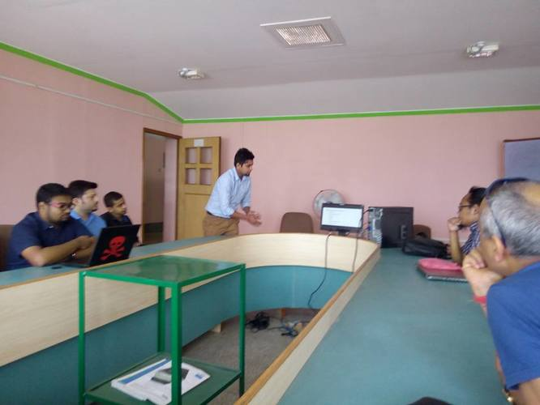

*We love new projects!  
Let's get started.*

PRESENTLY WE ARE INCUBATING AND/OR MENTORING

* [**Little Laureates**:](http://www.littlelaureates.com/) First Digitally Enabled and Virtually Networked Pre-School Chain in India providing holistic education to preschool children and parenting education to their parents ([www.littlelaureates.com](http://www.littlelaureates.com/))
* [**Ujjewaan Healthcare**](http://www.ujjeewan.com/)**:** Reaching out to the rural last mile for providing holistic health care through technology and process innovation ([www.ujjeewanhealthcare.com](http://www.ujjeewanhealthcare.com/))
* [**TotalAnima**](http://www.totalanima.in/)**:**A knowledge venture with [**Virtualinfocom**](http://www.virtualinfocom.com/) ([www.virtualinfocom.com](http://www.virtualinfocom.com/)) for developing animation and gaming software and providing training for creating resources for the game development and animation ([www.totalanima.in](http://www.totalanima.in/))
* [**TotalBizPro**](http://www.totalbizpro.com/)**:**A complete set of business solutions for Business Process Outsourcing, Customer Dialog Services and Knowledge Process Outsourcing ([www.totalbizpro.com](http://www.totalbizpro.com/))
* [**TotalPub**](http://www.totalinx.com/)**:**A complete set of business solutions and services for the E-Publishing and Pre-Press domain ([www.totalpub.com](http://www.totalinx.com/))
* [**TotalApp**](http://www.totalinx.com/)**:**A complete set of IT solutions and services to manage large complex business applications ([www.totalapp.com](http://www.totalinx.com/))

[**KNOW MORE ABOUT US**](http://www.totalstart.org/)

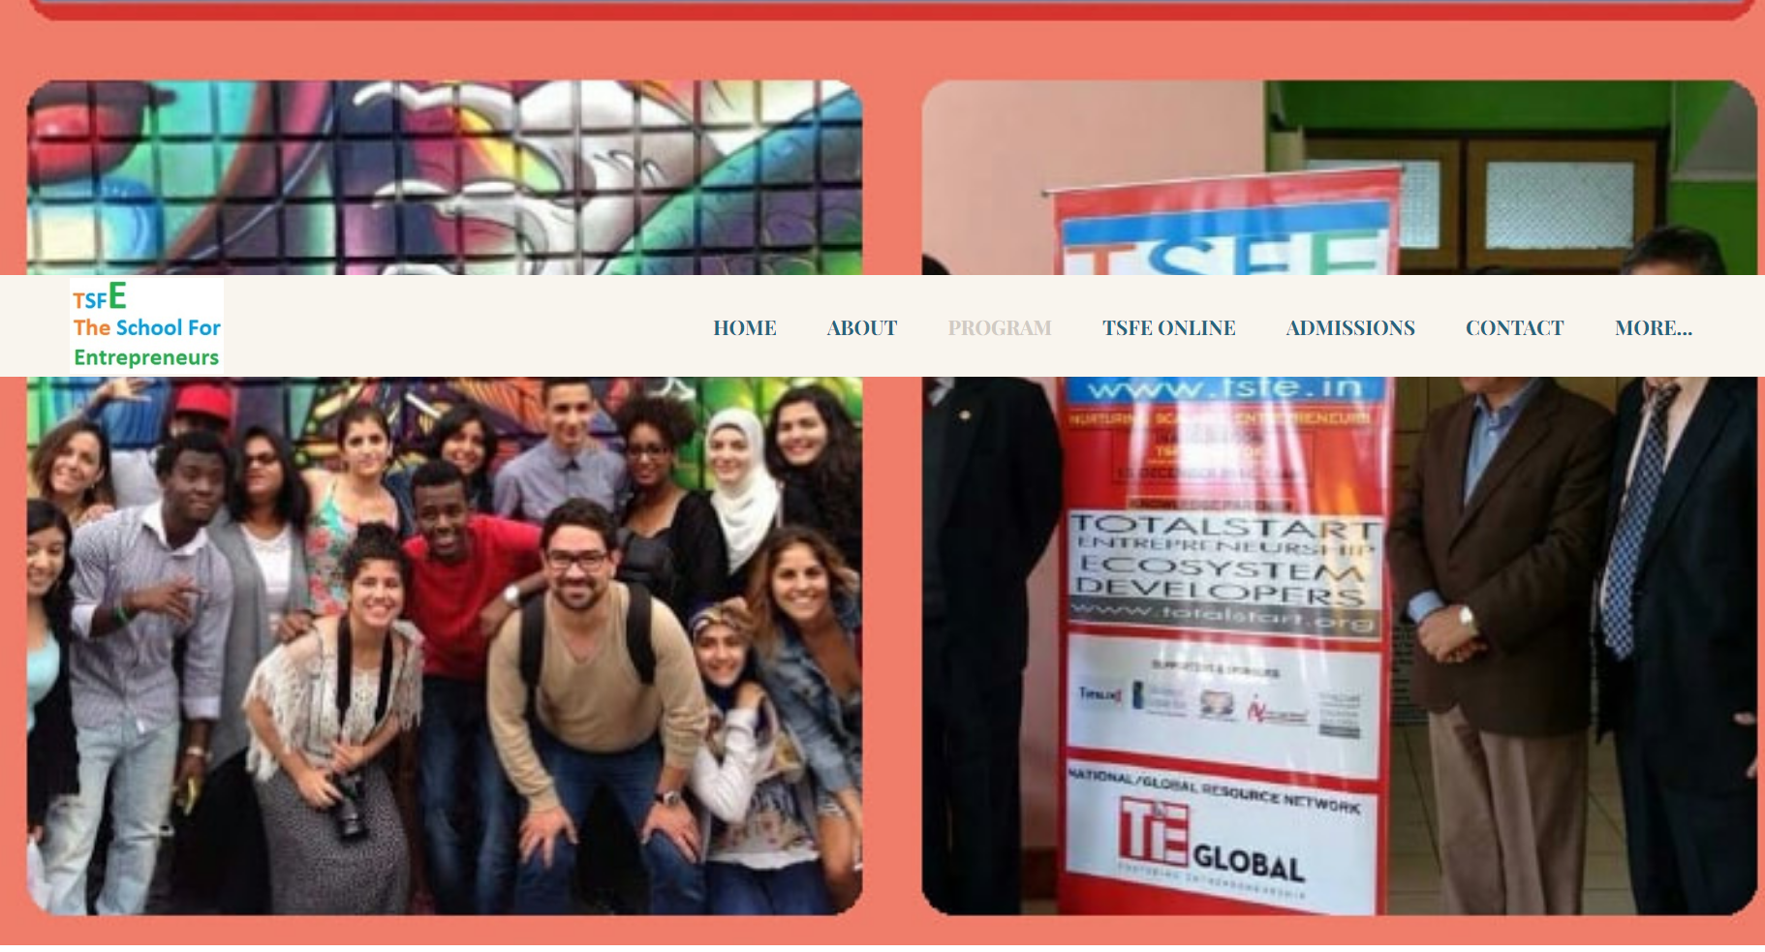

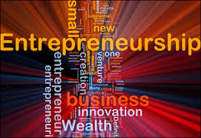

***The Program****Building an Entrepreneur**Year One - Learning Phase*

**Month 1 - Month 4  |***200 hrs of Entrepreneurship Related Subject Matter Coaching*  
Refer to course curriculum received after application  
**Month 1 - Month 4  |***200 hrs of Entrepreneurship Related Subject Matter Guided Self Learning*  
Refer to course curriculum received after application  
**Month 5 - Month 8  |***160 hrs of Workshop Based Hand Holding*  
Refer to course curriculum received after application  
**Month 5 - Month 8  |***240 hrs of Workshop Based Hand Holding Related Guided Assignments*  
Refer to course curriculum received after application

*Year One - Engagement Phase*

**Mpnth 9 - Month 12  |***240 hrs of engagement as an Apprentice with an entrepreneur in progress*  
  
**Month 9 - Month 12  |***Creating the baseline scalable business model and business plan*

1. Baseline first iteration opportunity identification and selection of three best ideas
2. Creating the baseline business model for the three ideas
3. Getting the three baseline business models evaluated by industry mentors during the parallelly apprentice engagement period
4. Grading the 3 business models as per scalability, fundability and actulization in terms of the local environment and resource context and constraints, and expanding on all three but based on the priority set for them

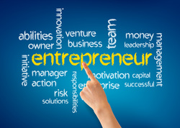

***The Program****Building of an Enterprise by the Entrepreneur**Year Two - Doing Phase*

**Month 1 - Month 3  |***Final Selection on 1 Business Model and fine-tuning it with all relevant research and market data after thorough market engagement*  
**Month 3 - Month 9  |***Implementation of the Proof of Concept through boot-strapping or small loans AND/OR angel funding*

*Year Two - Implementation & Funding or Fund Hunting Phase*

**Month 9 - Month 12 Plus  |***Enterprise Launching & Management*  
**Month 9 - Month 12         |***Guided Fund Raising*

***TSFE Online***

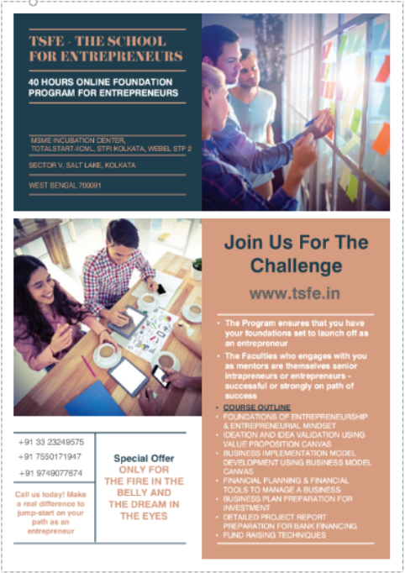

***TSFE OnLine***

**About**  
TotalStart Entrepreneurship Ecosystem Developers has launched TSFE Online starting from 1st January, 2021. It is a 20 or 40 hours program focusing on Entrepreneurship development among youths with education qualification of Graduation and above, and train them in Entrepreneurial skills. This program will also promote, aid, encourage, develop, protect and secure the interests of potential start-ups by providing education, training, guidance, mentoring and learning.  
  
**Program**  
The program ensures that you have your foundation set to launch off as an entrepreneur. Faculties engaged as mentors are themselves senior Intrapreneurs or entrepreneurs- successful or strongly on path of success. This program will focus on key parts of the foundation of entrepreneurship and entrepreneurial mindset.  
  
Foundation of Entrepreneurship:

* Understanding Difference between Business and Entrepreneurship
* Conceptual Knowledge on:
  + Business Strategy
  + Financial Planning/Accounting
  + Business Operation
  + Resource/People Management
  + Marketing and Sales
* Understanding Business Tools for creating an Enterprise
  + Value Proposition Canvas
  + Business Model Canvas
  + Financial Planning and Modeling
  + Detailed Project Report Preparation
  + Business Plan Preparation
* Hand Holding through workshops on:
  + Leadership skills
  + Business Communication Skills
* Developing an Entrepreneurial Mindset

**Application Process**  
Fill out the google form, clicking the button below. Please share details of your business ideas (if there are any) else write NA.  
AFTER FILLING OUT THE FORM PLEASE PAY ONLINE EITHER FOR THE 40 HRS PROGRAM OR FOR THE 20 HOURS PROGRAM MEANT FOR DIFFERENT CATEGORY OF PARTICIPANTS.

[**APPLY FOR TSFE ONLINE**](https://forms.gle/cWH1s2q8xX1AKKrt8)

Pay the Non-Refundable Fees by clicking on “Pay Now”. The Link will take you to our PayU payment Portal.  
Enrollment fee for the TSFE- Online, 40 hours program is Rs. 40,000 + 18% GST (FOR METRO, TIER-1 AND TIER-2 CITY EXISTING AND PROSPECTIVE ENTREPRENEURS)  
​**NOTE:**A COHORT OF 20 IS REQUIRED TO RUN THIS PROGRAM IN A FINANCIALLY SUSTAINABLE WAY

[](https://www.payumoney.com/paybypayumoney/#/8A752452D26E31CACEF440C49DF03842)

Pay the Non-Refundable Fees by clicking on “Pay Now”. The Link will take you to our PayU payment Portal.  
Enrollment fee for the TSFE- Online, 20+ hours program is Rs. 10,000 + 18% GST (FOR UNDERDEVELOPED REGIONS AND UNDERPRIVILEGED COMMUNITY EXISTING AND PROSPECTIVE ENTREPRENEURS).  
**NOTE:**A COHORT OF 20 IS REQUIRED TO RUN THIS PROGRAM IN A FINANCIALLY SUSTAINABLE WAY

[](https://www.payumoney.com/paybypayumoney/#/40A99F738ECB6E8FDE7175B97A4014BF)

​For any clarification or doubts, feel free to contact on the below mentioned email or phone.  
[director@tsfe.in](mailto:director@tsfe.in) | [tsfe.india@gmail.com](mailto:tsfe.india@gmail.com)  
[+91 9749077674](tel:919749077674) | [+91 8777652767](tel:918777652767)

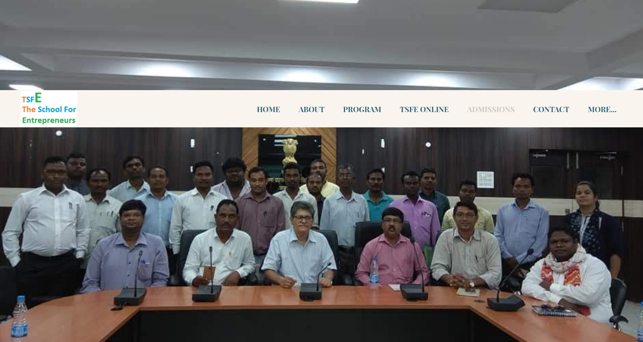

Undergraduates and Postgraduates in any discipline who wants to pursue the path of becoming an entrepreneur, be their own boss, have the opportunity to earn in crores, should positively explore TSFE - The School For Entrepreneurs' 2 year elite program which promises to deliver to you the following, if you have the hard capability to walk in full stride with us and have real fire in the belly:

1. **A running scalable and sustainable company at the end of 2 years**
2. **Initial Traction of revenue of up to Rs 10 lakhs at the end of the program**
3. **Sure Funding by Financial Institutions of up to Rs 1 crore**
4. **A certificate for successful program completion in Partnership with Indian Institute of Corporate Affairs, Ministry of Corporate Affairs, Govt. Of India**
5. **In case a student is not keen to pursue a career in Entrepreneurship, with the experience gained through this program, a sure shot opportunity to be placed in a good company as an intrapreneur manager**
6. **This program is run by the best resources pulled from the Entrepreneurship World in India who are either established Entrepreneurs or top intrapreneur managers from leading companies in the country**

TSFE has been opened simultaneously in 4 states in India: Sikkim (Gangtok), Tripura (Agartala), Uttarakhand (Kathgodam), West Bengal (Kolkata)  
So do not delay any further and whatsapp or sms to +917003625772 or email to admissions@tsfe.in to support and participate in India's Startup India Movement!

*Admissions Criteria*

**Minimum Educational Qualification:**

* Bachelors Degree in Arts, Science, Engineering, Management, etc.
* Diploma Holders and Class 12 Pass outs can fulfill the criteria after a preliminary but exhaustive test

**Admission Process:**

* A 5 page 500 line essay as to why you want to be an entrepreneur
* EQ Test
* 2 Levels of Interviews
* Fast Thinking Extempore Speech
* Group Discussion

**Application Fee for Admission:​**

* Rs. Three Thousand Only

**Fee Structure:**

* **Year One:**Rs Five Lakhs Only, Payable at the time of admission
* **Year Two:**Rs Two Lakhs Only, Payable at the time of the award of First Year's Certificate on completion of Year One

**Method of Payment:**

* ​Payable Through Bank Transfer to TOTALSTART ENTREPRENEURSHIP ECOSYSTEM DEVELOPERS | Bank Account Number: 037101005990 | Bank Name: ICICI Bank Ltd., VIP Road Branch, Kolkata | IFS Code: ICIC0000371

[**APPLY ONLINE**](https://docs.google.com/forms/d/15jGSXBAVaQlMwEFHd9ZqJwwBQISo-1p-tf4ujdkP5UM/viewform)

Top of Form

*OR CONTACT FOR DETAILS*

Bottom of Form

*Recent News*

CHECK OUT OUR FACEBOOK LINKS FOR ALL RECENT NEWS!  
[PAGE](https://www.facebook.com/TSFE.IN/)

*Subscribe to News & News Letter*

Top of Form

* Indicates required field

Email *

**Submit**

Bottom of Form

https://www.facebook.com/TSFE.IN/  
​[GROUP](https://www.facebook.com/TSFE.IN/)  
https://www.facebook.com/groups/1151534924867492/

*OR CONTACT FOR DETAILS*

* Indicates required field

Name *

First

Last

Mobile Number *

Email Adress *

**Submit**

**We are here  to take you ON THE UNBEATEN PATH OF GLORY**

***Contact Us***

**We are here to take you on the unbeaten path of glory  
We ensure that the hidden or flourishing spirit of entrepreneurship is unfurled in you  
We school the creation and take off of scalable enterprises by you**

|  |  |  |  |
| --- | --- | --- | --- |
| ***TSFE - The School For Entrepreneurs @ Gangtok***  **Located at:** **​TotalStart Sikkim Innovation & Incubation Center** ​Software Technology Parks of India - Gangtok, Sikkim Jewel Complex, Tadong, NH 31 A, Gangtok, SIKKIM INDIA ​737102 ​Tel: +91 3592 271193 ​Email: gangtok@tsfe.in ​Central Mobile / WhatApp: +91 7003625771 / +91 7003625772 *TSFWE - The School For Women Entrepreneurs @ Kolkata* **Located at:** **TotalStart Bengal Innovation & Incubation Center** STPI Kolkata, 2nd Floor, WEBEL STP - 2, DN-53, Sector V, Salt Lake, Kolkata, ​WEST BENGAL INDIA 700091 ​ ​Tel: +91 33 2367 3798/3799 ​Email: kolkata@tsfe.in ​Central Mobile / WhatApp: +91 7003625771 / +91 7003625772  ***​***[***TSFWE​ - The School For Women Entrepreneurs***](https://youtu.be/OEnri51Gjf4)   |  | | --- | | [**Women with Fire & Dream your journey begins here**](https://youtu.be/OEnri51Gjf4)  **Inauguration of** [**TSFWE**](https://www.facebook.com/hashtag/tsfwe?source=feed_text&epa=HASHTAG&__xts__%5B0%5D=68.ARC73gfU_0wG_r3vfpSBJRT52J673nvRC80Rqie5KcdzmuQRtDWrtw1TNlverwR0idEMWB7C2dxGSBxHzX-yk9CpUR6_o1dJ4HBfAfuCZ2Ax7ksd8eJ2-8LQuy51FzO_1Rl83ksQgOO00w_3D19gLgefXH6_qU0PZja1SwDMj4Lz0rvhJ9HY-9bKP5JMg5tzr-4JsoV4SKY8J5CWWJ_ft9PPSDGvljFtR_-YYfN3qDESqgRlhDWXdoaSGAUaqgFsOZm1Q-gUy34FoG2OtC80eqzxOzdXz7VhRV4tRpWAaPryKNvluvhXgIny1GY9bRLq0kJuGNrso9fhvrO4BoEAfw7M9IPTrpJWcJ8YbCTEgrwivm6K0zc&__tn__=%2ANK-R)**- The School For Women Entrepreneurs  and launch of 3 months - Women Entrepreneur in Residence Program**  **An exclusive informal launch gathering of micro women entrepreneurs and startups from the Districts of Eastern and North Eastern**  **States of India with key event speakers being Senior Women Entrepreneurs and Leaders from this region** **Venue: Conference Room, TotalStart - IICML, STPI Kolkata, WEBEL STP - 2, DN-53, Sector V, Salt Lake, Kolkata 700091 Date: 8th March 2019 Time: 2:00 - 5:00 pm** **We thank you for your kind presence as our guest and as a woman entrepreneur**  **Let us fire it up and dream it out-** [**https://youtu.be/PYjnF01OjyQ**](https://youtu.be/PYjnF01OjyQ)  [**TSFWE launches 3 months Women Entrepreneur in Residence Program @ Kolkata**](https://www.facebook.com/events/254464422154804)  **Details** [**TSFWE**](https://www.facebook.com/hashtag/tsfwe)**-The School For Women Entrepreneurs** is launching a 3 month intensive boot camp in Kolkata,  for women micro entrepreneurs and young women startups from the Districts in West Bengal through [**TSFE**](https://www.facebook.com/hashtag/tsfe)**- The School For Entrepreurs** .  Please spread the message below to all who will possibly benefit from it.  The program will be launched on 8th March 2019 on the International Women's Day at TotalStart's Kolkata HQ at STPI Kolkata,  DN-53 Sector V, Salt Lake, Kolkata 700091  We will kick start the 3 month bootcamp first. And in that 3 month bootcamp we will have 1 week focussed for all  National Entrepreneurship Awards [www.neas.in](https://l.facebook.com/l.php?u=http%3A%2F%2Fwww.neas.in%2F%3Ffbclid%3DIwAR2BMreHaddTDJzup2LKIQFYQaTp1JsGaYY56ukAx0n6ATiVx0hejsTgXn4&h=AT0Uj2-7mmmvo_spYxlbWx940pyPfgCgPY5cCNQmtHGkGJ1GI7gSn-JIktkFQqpEqk6sxdODbjTzcHIE82q-zefYu8vkkvgKbazAasQ4P-oHRMCQGsaDGTFxHS1yryFRt6HCdDbq_mfO) winners who are interested. At the 3 month bootcamp end we will celebrate NEA  winners of 2018, along with the bootcamp graduation ceremony.  This is also open for all women entrepreneurs from [#Eastern](https://www.facebook.com/hashtag/eastern) and [#North](https://www.facebook.com/hashtag/north) #Eastern [#States](https://www.facebook.com/hashtag/states) of India   ---------------------------- Thank you for your interest in TSFWE's program: [**Click here to apply**](https://docs.google.com/forms/d/e/1FAIpQLSeBrHbmCdg6zz7Sc7OocQAyKCA_M055E0ahO2jzQcSrwHp6gQ/viewform) Please go to the link here and fill out the detailed form for application to be admitted to TSFWE - The School For Entrepreneurs  for it's 3 months program starting in April 2019 for "Women Entrepreneur in Residence"  We are launching a business model competition in April 2019 for which we will reach out to 1000+ women youth and  prospective entrepreneurs, pick up 100 best from them, train them strongly for 1 month. Make them work on a business model plan and  make them compete in a competition and we will pick the first 20 to go through the 2 year program of #TSFWE –  The School For Women Entrepreneurs [www.tsfe.in](https://l.facebook.com/l.php?u=http%3A%2F%2Fwww.tsfe.in%2F%3Ffbclid%3DIwAR03zzzzydQkK9kB2nQ_X7c7MGUR58apjLYFGZq0aucs-PmUc0_CkXY-WSc&h=AT0b4PrQkewDw7Rkpnl25Kn244eBx-Or4BXCLOyrbXI_3FiSyiDA2kCyRedUbvbt9LBWxDR3BcZxOrhwTfFmWU8h1Z6iGDpB8LKj9XQEjGmixX2ZoDr0cvYZZ1oU9LnT7v54LENyiW2b) which we are setting up in Kolkata area for young women micro  entrepreneurs which will kick start on 1st of April in Bengal with the first cohort of 20 women micro entrepreneurs.   Best wishes,  Director TSFE - The School For Entrepreneurs TSFWE - The School For Women Entrepreurs [www.tsfe.in](https://l.facebook.com/l.php?u=http%3A%2F%2Fwww.tsfe.in%2F%3Ffbclid%3DIwAR16otYeP4ezDwHlwu6ErT2wJXd_sEBN8t_nkzJF4EMRTp8lO67IkcGbiaU&h=AT0b4PrQkewDw7Rkpnl25Kn244eBx-Or4BXCLOyrbXI_3FiSyiDA2kCyRedUbvbt9LBWxDR3BcZxOrhwTfFmWU8h1Z6iGDpB8LKj9XQEjGmixX2ZoDr0cvYZZ1oU9LnT7v54LENyiW2b) WhatsApp: 7003625771 Mobile: 9749077674 Centres at: Kolkata, Gangtok, Imphal (Opening soon), East Singbhum (Opening soon) Agartala (Opening soon)  Darjeeling/Kalimpong (Opening soon) [#innovation](https://www.facebook.com/hashtag/innovation) [#inspiration](https://www.facebook.com/hashtag/inspiration) [#entrepreneurship](https://www.facebook.com/hashtag/entrepreneurship) [#entrepreneurs](https://www.facebook.com/hashtag/entrepreneurs) [#sustainability](https://www.facebook.com/hashtag/sustainability) [#workshop](https://www.facebook.com/hashtag/workshop) [#planning](https://www.facebook.com/hashtag/planning) [#value](https://www.facebook.com/hashtag/value) [#business](https://www.facebook.com/hashtag/business) [#MSME](https://www.facebook.com/hashtag/msme) | | ***TSFE - The School For Entrepreneurs @ Jadugoda***  **Located at:** **TotalStart Jharkhand MSME Innovation & Incubation Center​** Murmu Complex Machuabazar, Jadugoda East Singbhum, JHARKHAND INDIA 832102 ​Tel: +91 9431310128 / 6203449198 ​Email: jadugoda@tsfe.in ​Central Mobile / WhatApp: +91 7003625771 / +91 7003625772 | ***TSFWE - The School For Women Entrepreneurs @ Kolkata***  **Located at:** **TotalStart Bengal Innovation & Incubation Center** STPI Kolkata, 2nd Floor, WEBEL STP - 2, DN-53, Sector V, Salt Lake, Kolkata, ​WEST BENGAL INDIA 700091 ​ ​Tel: +91 33 2367 3798/3799 ​Email: kolkata@tsfe.in ​Central Mobile / WhatApp: +91 7003625771 / +91 7003625772 |

***TSFE - Jharkhand***

|  |
| --- |
|  |

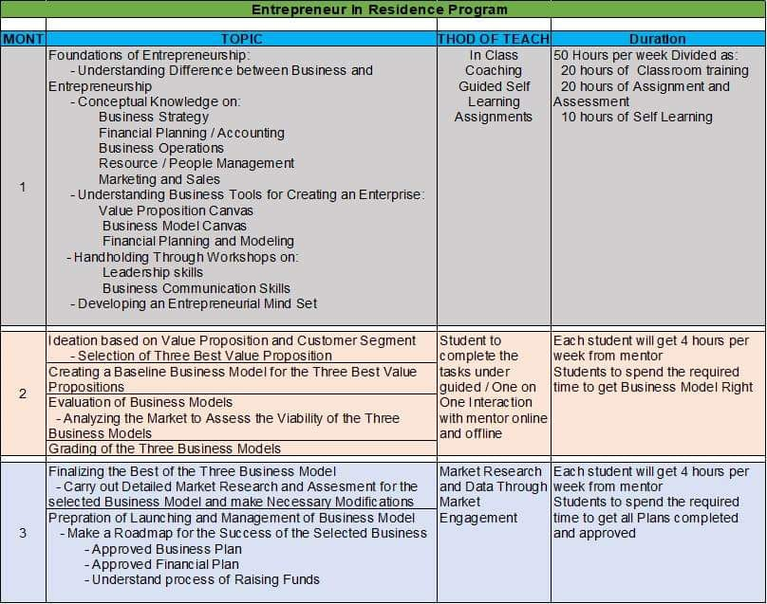 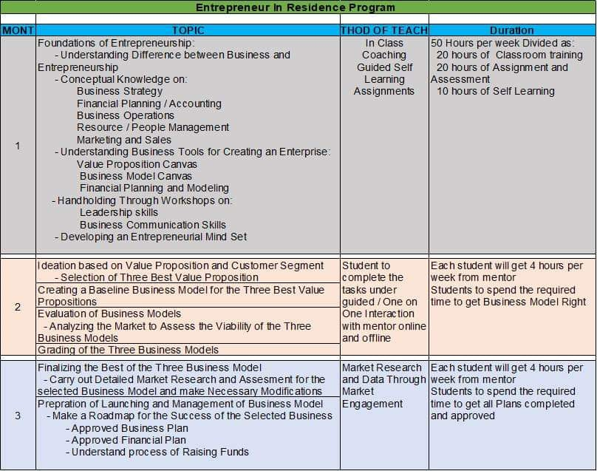

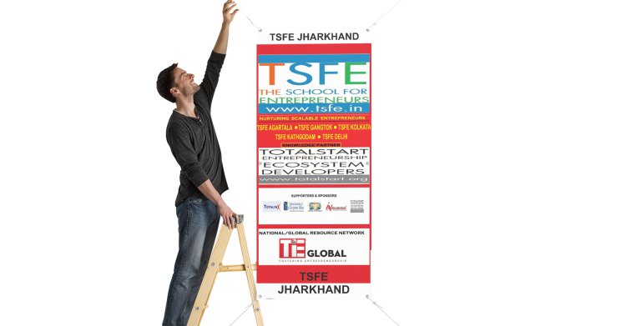

***Team TSFE Jharkhand @Jadugoda***

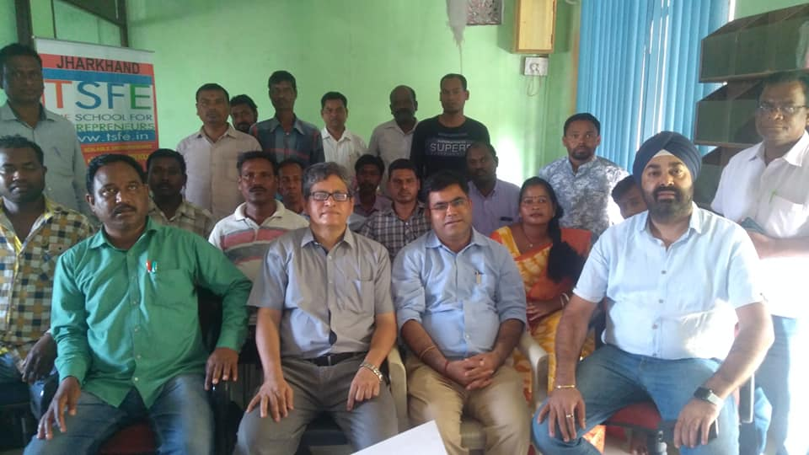

**TSFE Jharkhand @Jadugoda Team, Picture (L-R)**: [Mr. Khelaram Murmu](https://www.facebook.com/khelaram.murmu.7777) (President), [Dr. Suryanil Ghosh](http://www.linkedin.com/in/shurjo) (Chairman)  
[Mr. Atul Puri](http://www.linkedin.com/in/atulpuri) (Mentor & Governance Board Member), [Mr. Gurmeet Singh](https://www.linkedin.com/in/gurs05/) (Mentor and Governance Board Member)

We are launching a 3 month intensive boot camp in East and West Singhbhum Districts in Jharkhand for local micro entrepreneurs and young startups from the tribal community through [#TSFE](https://www.linkedin.com/feed/hashtag/?keywords=%23TSFE) - The School for Entrepreneurs [www.tsfe.in](http://www.tsfe.in/) launch at Jadugoda, East Singbhum, Jharkhand. On 25th March 2019 with the first 10 day boot camp it starts followed by the formal inauguration on the 3rd. of April 2019. Please spread the message below to all who will possibly benefit from it. You are all cordially invited for the inaugural event on the 28th. March 2019 in Jadugoda.  
[#bootcamp](https://www.linkedin.com/feed/hashtag/?keywords=%23bootcamp) [#tribal](https://www.linkedin.com/feed/hashtag/?keywords=%23tribal) [#communities](https://www.linkedin.com/feed/hashtag/?keywords=%23communities) [#entrepreneurship](https://www.linkedin.com/feed/hashtag/?keywords=%23entrepreneurship) [#underprivileged](https://www.linkedin.com/feed/hashtag/?keywords=%23underprivileged) [#inspiration](https://www.linkedin.com/feed/hashtag/?keywords=%23inspiration) [#school](https://www.linkedin.com/feed/hashtag/?keywords=%23school) [#micros](https://www.linkedin.com/feed/hashtag/?keywords=%23micros) [#youthempowerment](https://www.linkedin.com/feed/hashtag/?keywords=%23youthempowerment) [#uneducated](https://www.linkedin.com/feed/hashtag/?keywords=%23uneducated) [#networking](https://www.linkedin.com/feed/hashtag/?keywords=%23networking) [#community](https://www.linkedin.com/feed/hashtag/?keywords=%23community)

Thank you for your interest in TSFE's program:  
[https://lnkd.in/fG5j49V](https://lnkd.in/fG5j49V?fbclid=IwAR3oPOLknNWysEQhKDg46WxA5wqh0smAklcMYNIw3HQd3KUbzPYQVE-Yt30)  
Please go to the link here and fill out the detailed form for application to be admitted to TSFE - The School For Entrepreneurs for it's 3 months program starting in April 2019 for "Entrepreneur in Residence"  
To register and enroll in the program click here:  
[https://www.payumoney.com/events/#/buyTickets/EntrepreneurInResidenceProgram-Jan2019](https://www.payumoney.com/events/?fbclid=IwAR3oPOLknNWysEQhKDg46WxA5wqh0smAklcMYNIw3HQd3KUbzPYQVE-Yt30#/buyTickets/EntrepreneurInResidenceProgram-Jan2019)  
We are launching a business model competition in April 2019 for which we will reach out to 500+ tribal youth and prospective entrepreneurs, pick up 100 best from them, train them strongly for 10 days in 4 batches across East and West Singbhum in Jadugoda, Ghatshila, Chaibasa and Chakradharpur. Make them work on a business model plan and make them compete in a competition and we will pick the first 20 to go through the 2 year program of #TSFE - The School For Entrepreneurs [www.tsfe.in](https://l.facebook.com/l.php?u=http%3A%2F%2Fwww.tsfe.in%2F%3Ffbclid%3DIwAR3wYj2g0tHVkTCep7DgHEGGXsQ88Gm447ISOtFRwfqiV5EfKgfbCyge_xk&h=AT31J-tEwiY3lJS0MJwVVGJ985JgT0yOQ_QyTat1fUFFsSvnpjnEiytKy5FzzA3G0XhY5kfh_JiVbkCmtYGIZeltJGotsd0LO7cfdqPixc3YTj1BeO2pvTiqROygHbeny5Rf1fNSsm3Z) which we are setting up in Jadugoda, East Singhbhum, Jharkhand for micro Entrepreneurs and startups, which will kick start on 20th. of March in Jadugoda, East Singhbhum with the first two cohorts of 25 micro entrepreneurs to have the first 10 days boot camp in Jadugoda and Ghatshila.  
Supported by Dept. of MSME Govt. Of India.  
The first 10 days entrepreneurship training program is free and a certificate will be provided by the MSME Dept. Govt. Of India.  
Best wishes,  
Director  
TSFE - The School For Entrepreneurs  
[www.tsfe.in](https://l.facebook.com/l.php?u=http%3A%2F%2Fwww.tsfe.in%2F%3Ffbclid%3DIwAR2BNFPhvQkCDh09D1Uvbtm93LCTyIVOK_TPBWh7HjXKBfxDK0BmprKpaKE&h=AT31J-tEwiY3lJS0MJwVVGJ985JgT0yOQ_QyTat1fUFFsSvnpjnEiytKy5FzzA3G0XhY5kfh_JiVbkCmtYGIZeltJGotsd0LO7cfdqPixc3YTj1BeO2pvTiqROygHbeny5Rf1fNSsm3Z)  
WhatsApp: 7003625771  
Mobile: 9749077674  
Centres at: Kolkata, Gangtok, Solan (Opening soon), Imphal (Opening soon), East Singbhum (Opening soon)  
[#innovation](https://www.facebook.com/hashtag/innovation) #inspiration #entrepreneurship [#entrepreneurs](https://www.facebook.com/hashtag/entrepreneurs) [#sustainability](https://www.facebook.com/hashtag/sustainability) [#workshop](https://www.facebook.com/hashtag/workshop) [#planning](https://www.facebook.com/hashtag/planning) [#value](https://www.facebook.com/hashtag/value) [#business](https://www.facebook.com/hashtag/business) [#MSME](https://www.facebook.com/hashtag/msme)

***TSFE-Jharkhand - Story till date since May 2018***

|  |
| --- |
|  |

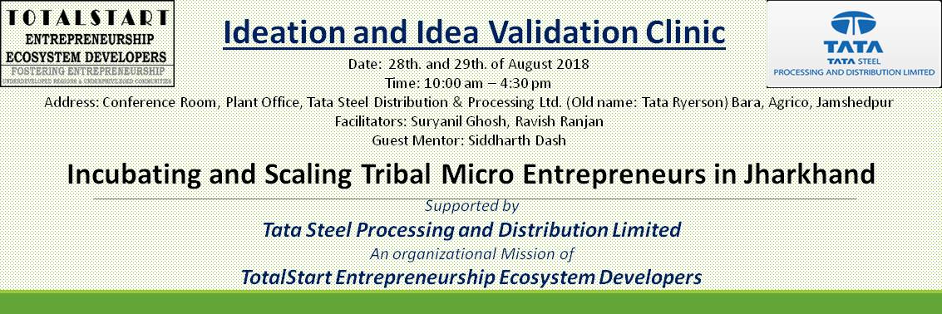

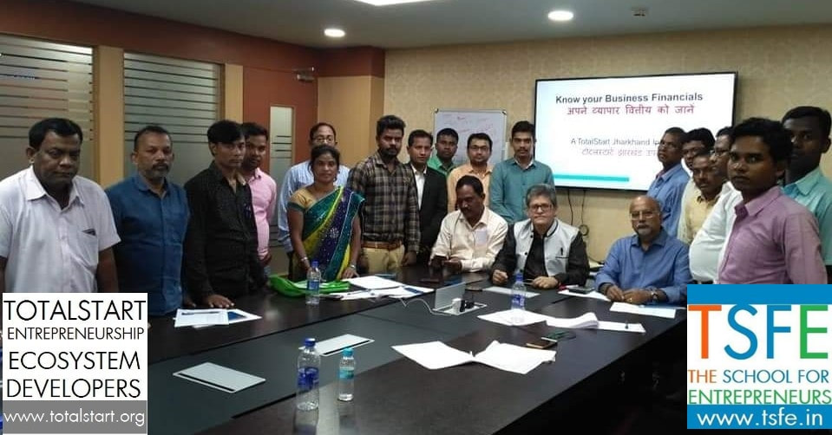

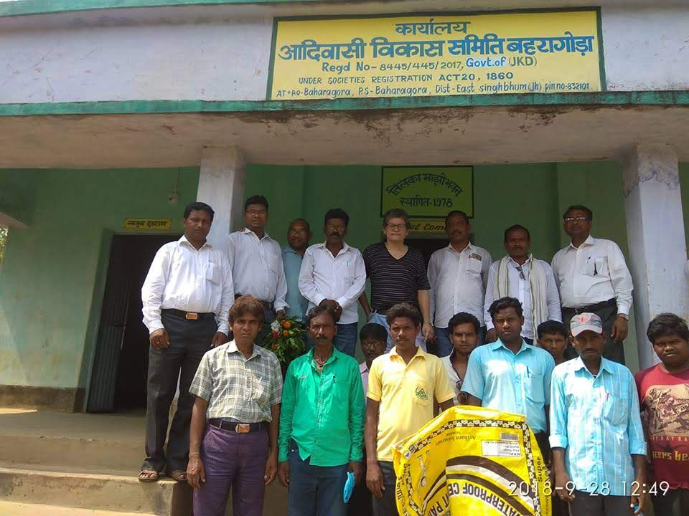

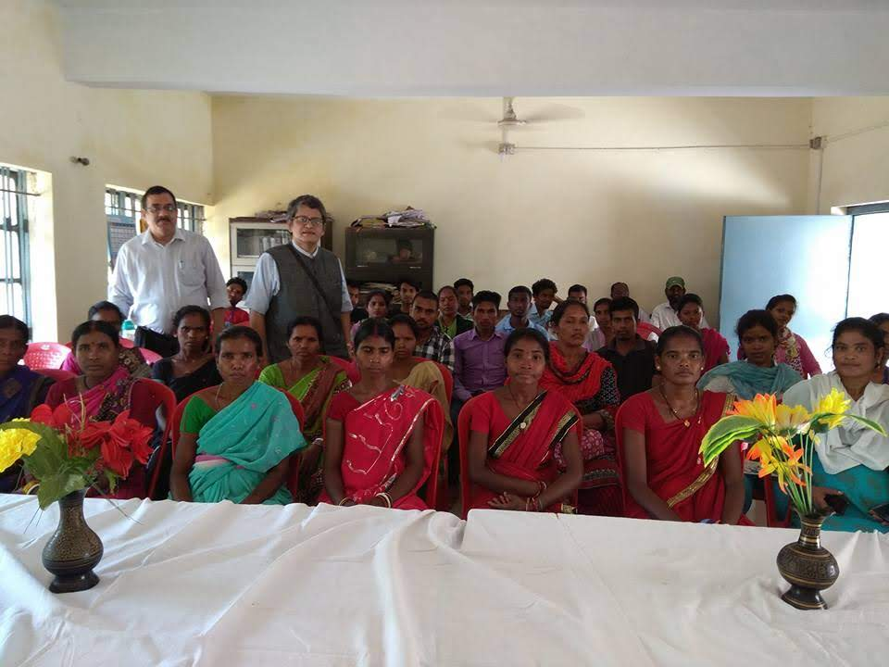

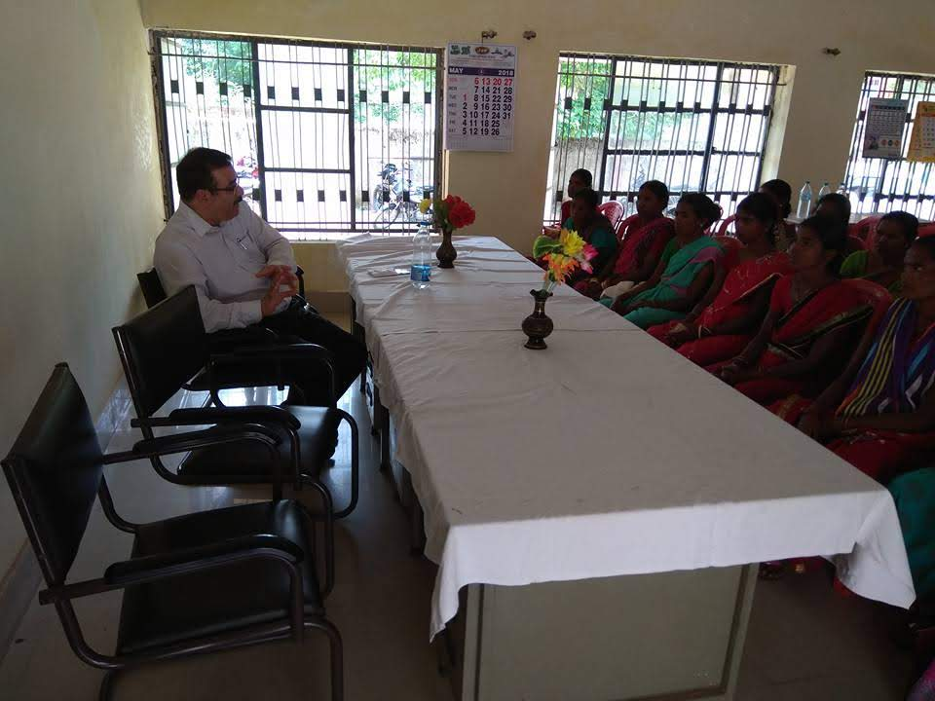

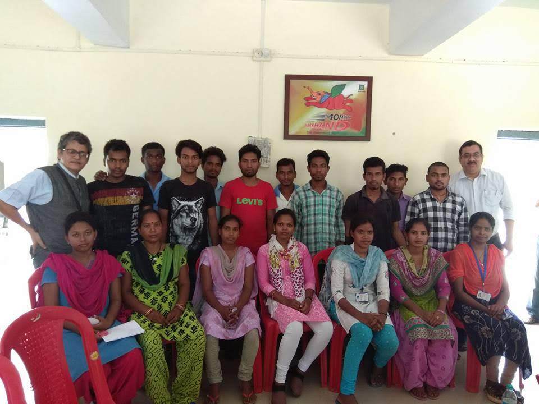

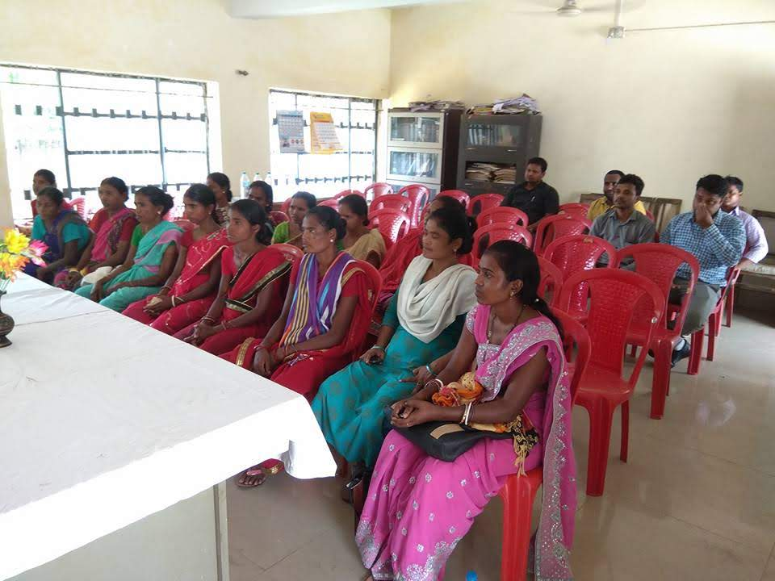

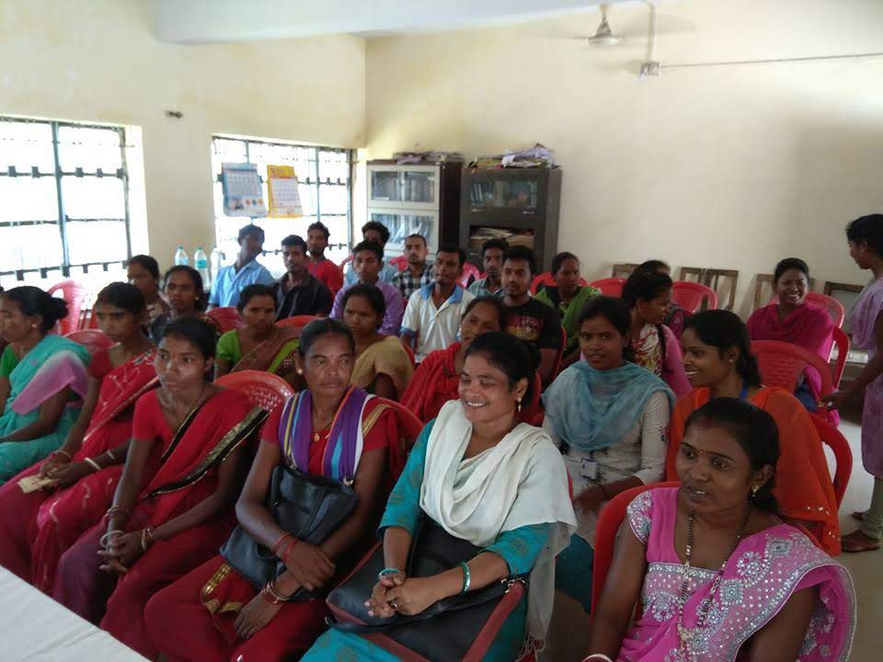

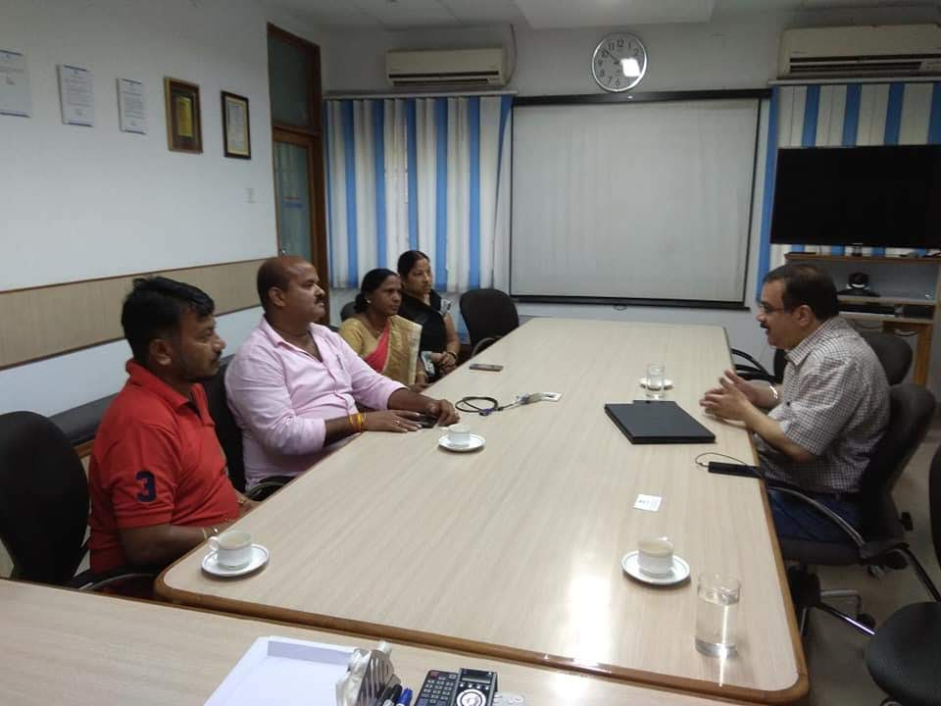

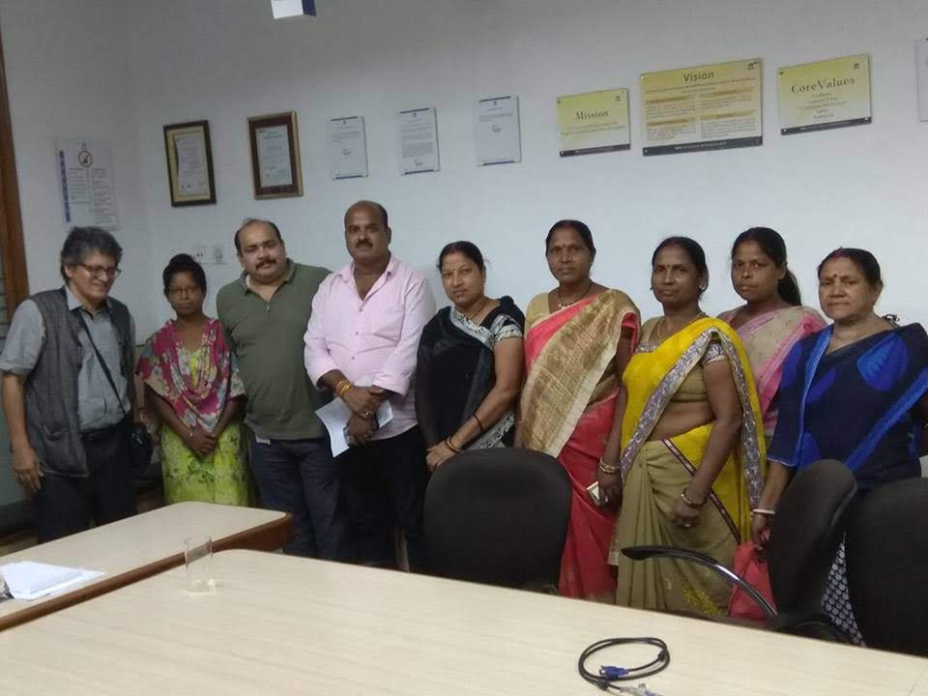

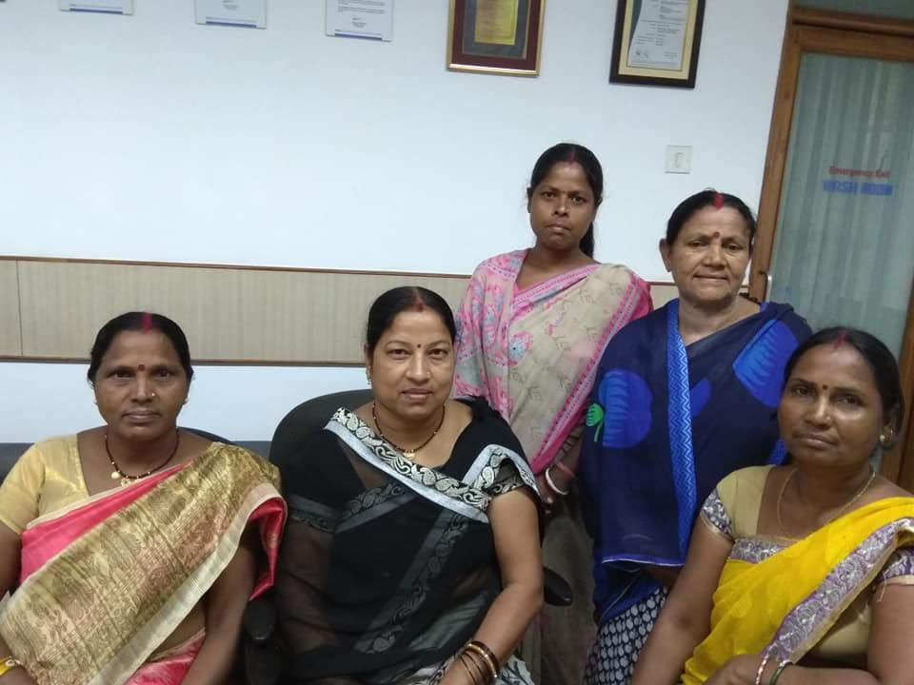

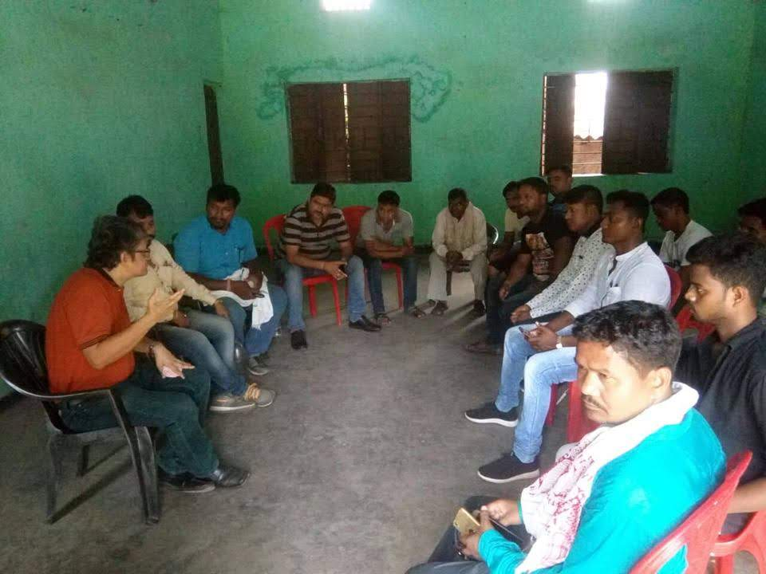

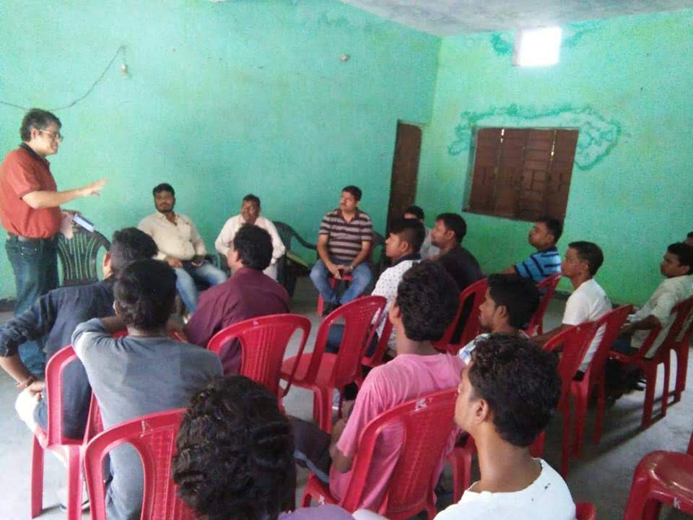

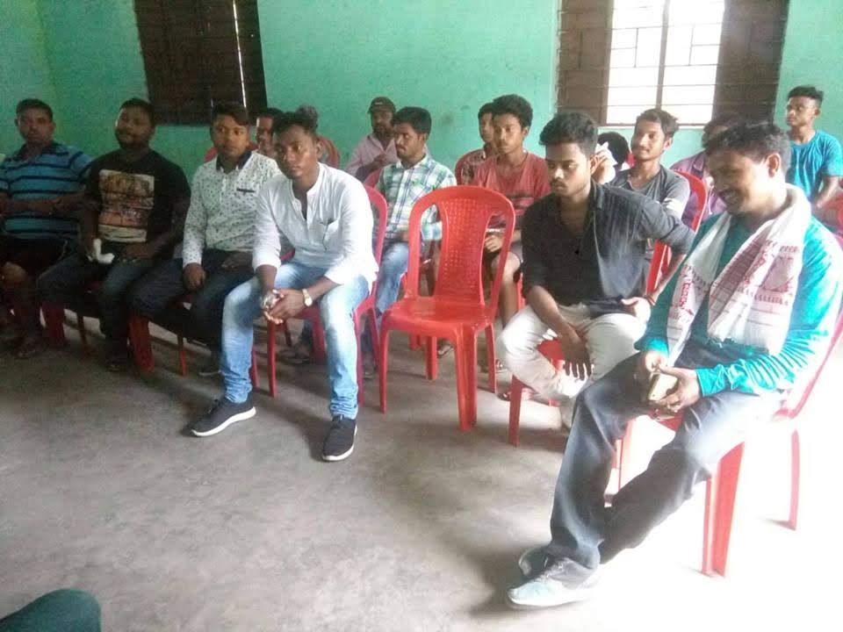

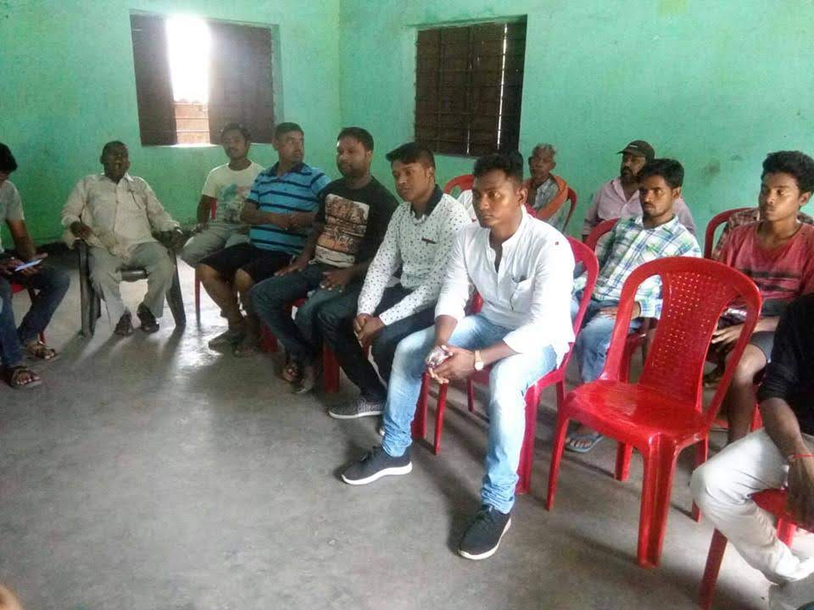

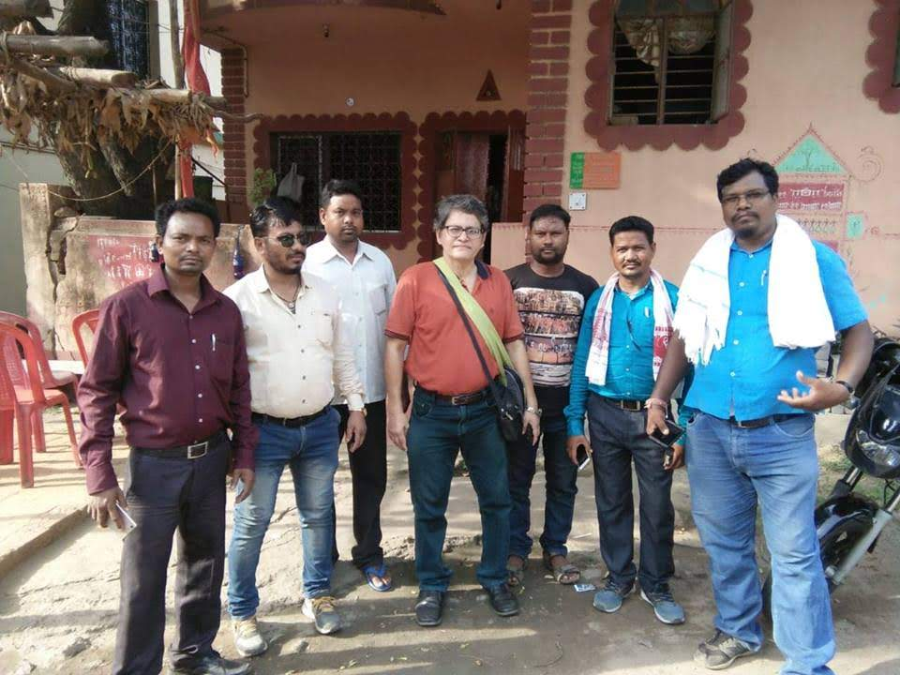

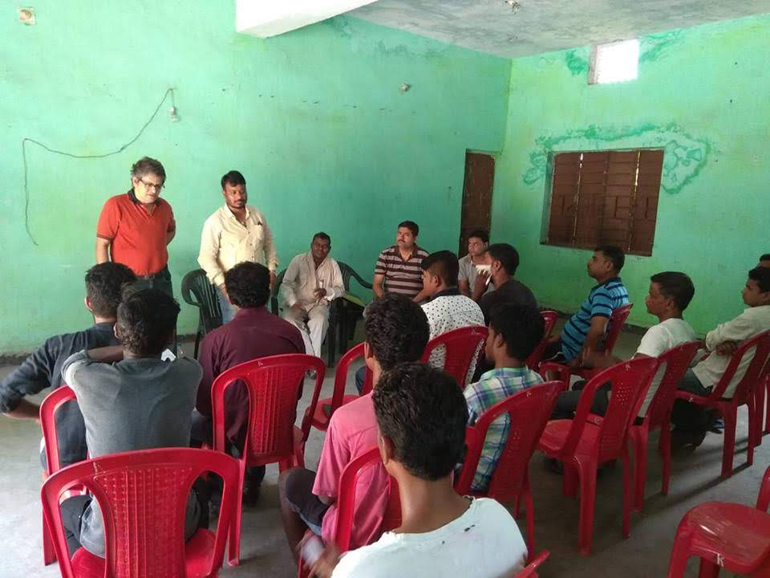

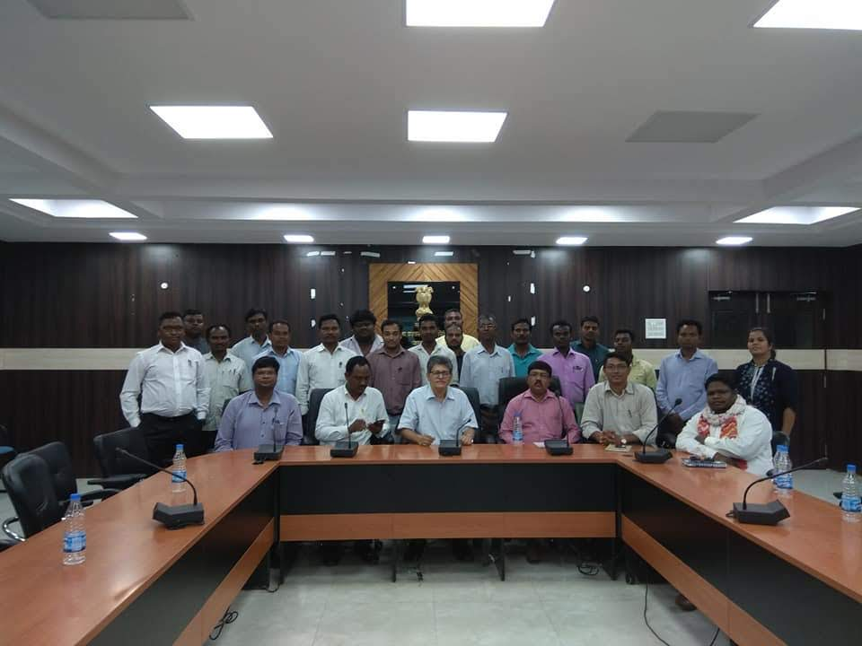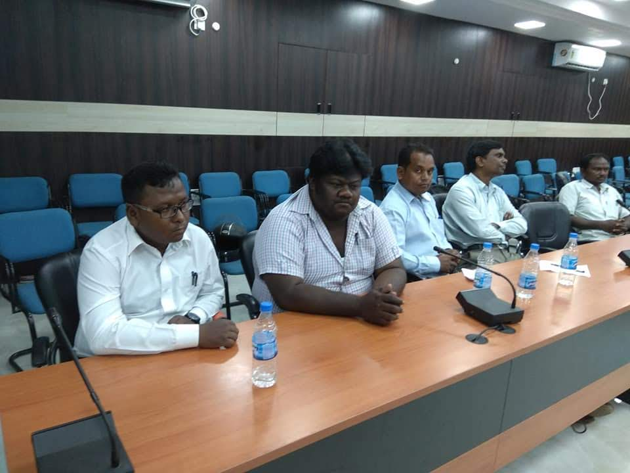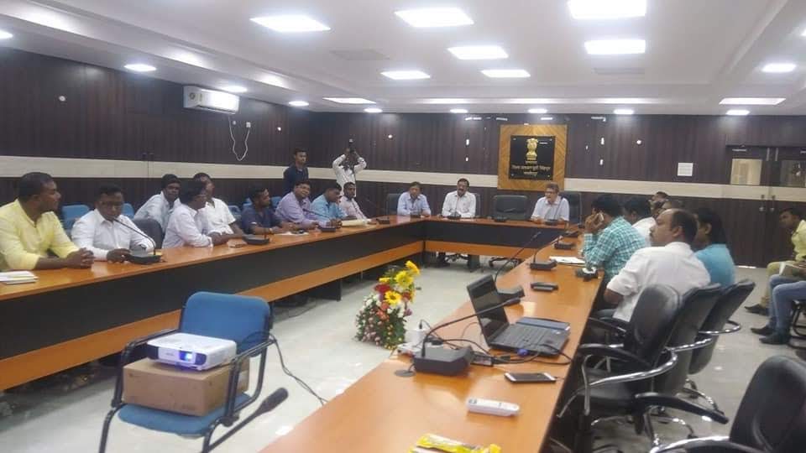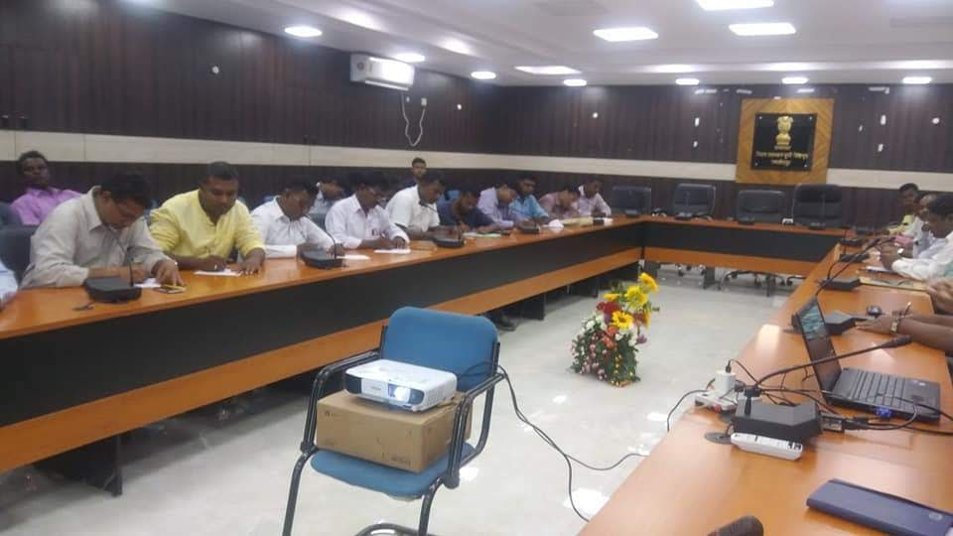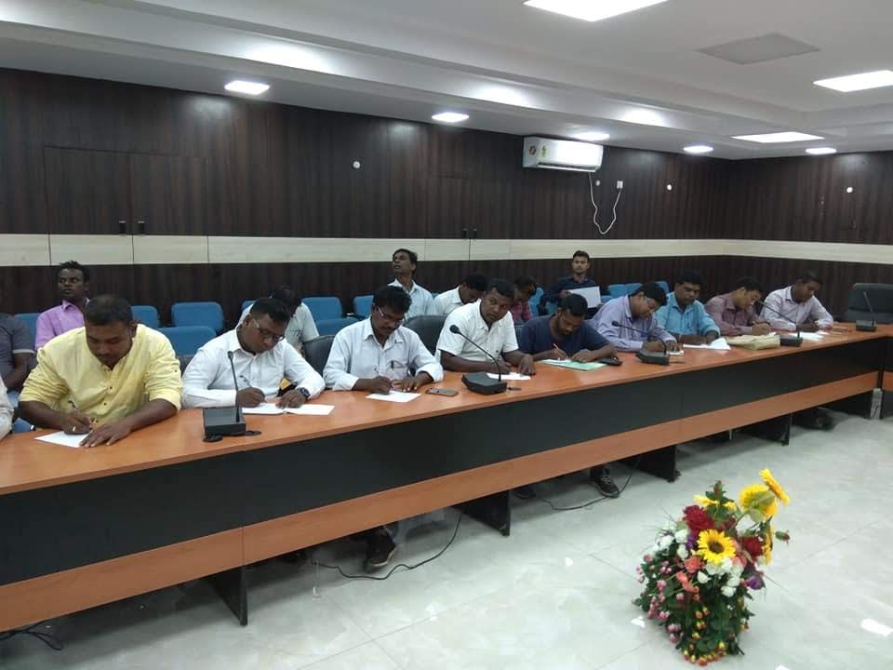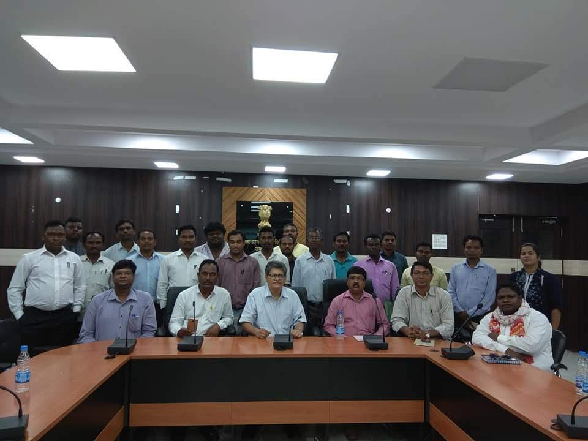

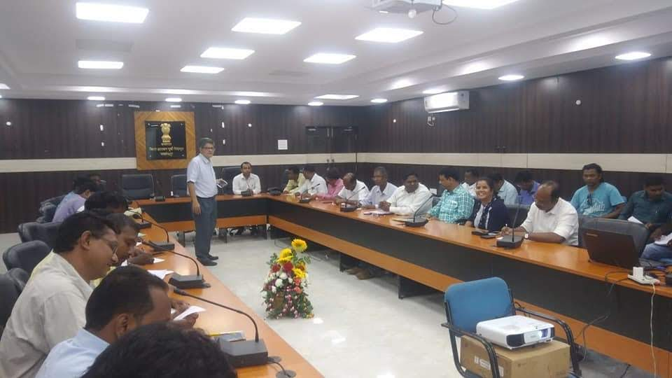

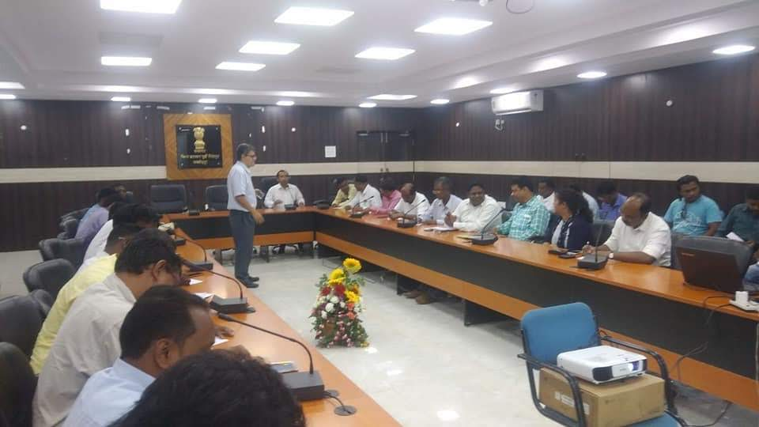

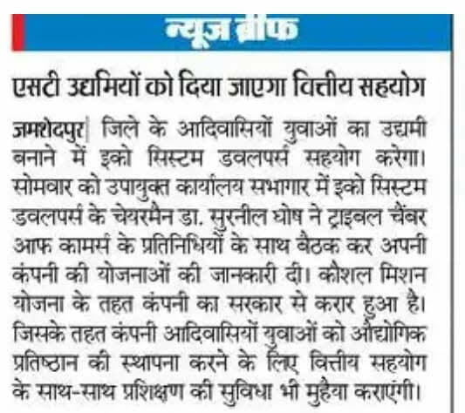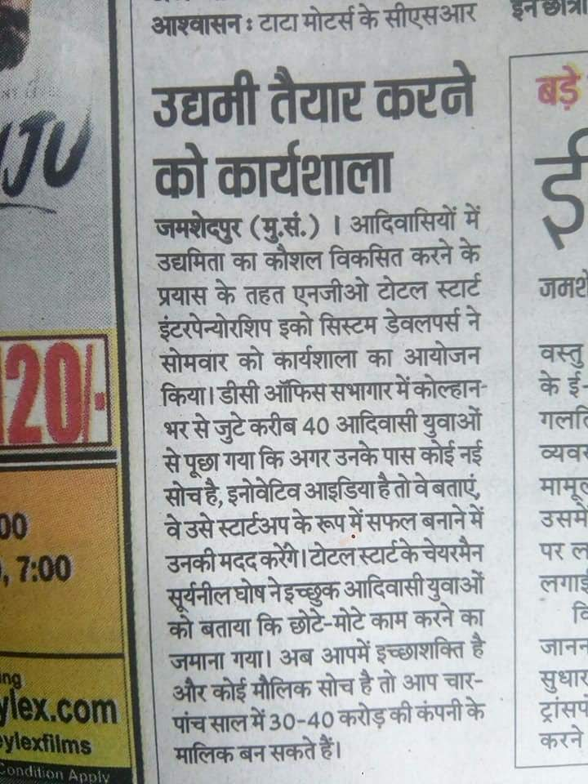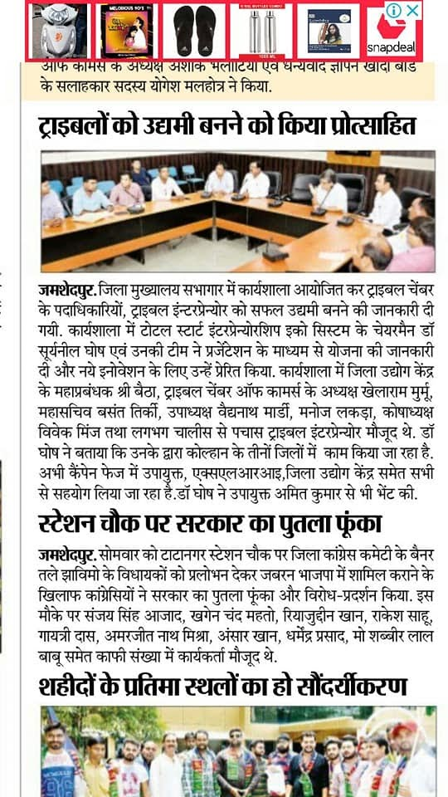

***Entrepreneur in Residence Program***

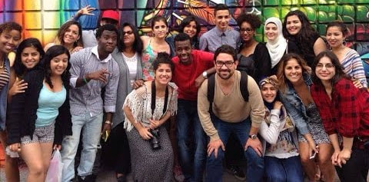

We are launching a series of 3 months intensive boot camps in

* Agartala - Tripura
* Gangtok - Sikkim
* East Singbhum - Jharkhand
* Darjeeling - West Bengal
* Imphal - Manipur
* Kolkata - West Bengal (for women only)

for micro entrepreneurs and young startups through [**TSFE - The School for Entrepreneurs**](http://www,tsfe.in/). Please spread the message below to all who will possibly benefit from it.   
----------------------------   
Thank you for your interest in TSFE's program:   
[**Please click here to apply**](https://docs.google.com/forms/d/e/1FAIpQLSeBrHbmCdg6zz7Sc7OocQAyKCA_M055E0ahO2jzQcSrwHp6gQ/viewform)  
Please go to the link here and fill out the detailed form for application to be admitted to TSFE - The School For Entrepreneurs for it's 3 months program starting in April 2019 for "Entrepreneur in Residence".  
We are launching a business model competition in April 2019 for which we will reach out to 1000+ youth and prospective entrepreneurs in the respective states, pick up 100 best from them, train them strongly for 1 month. Make them work on a business model plan and make them compete in a competition and we will pick the first 20 to go through the 2 year program at TSFE - The School For Entrepreneurs www.tsfe.in which we are launching in all the six states for young micro entrepreneurs, which will kick start on 1st of April 2019 with the first cohort of 20 micro entrepreneurs in select states where there is strong desire to become scalable entrepreneurs.  
  
Best wishes,   
Director   
TSFE - The School For Entrepreneurs   
www.tsfe.in   
WhatsApp: +91 7003625771 / +91 7003625772   
Mobile: +91 9749077674  
Centres at: Kolkata, Gangtok,  Imphal (Opening soon), East Singbhum (Opening soon) Agartala (Opening soon) Darjeeling (Opening soon)  
**#innovation #inspiration #entrepreneurship #entrepreneurs #sustainability #workshop #planning #value #business #MSME**

***Contact Us***

Let your visitors know how you would like stay in touch.

|  |  |  |  |
| --- | --- | --- | --- |
| Top of Form  * Indicates required field   |  |  | | --- | --- | | First Name * | Last Name * |   Email *  **Submit**  Bottom of Form |  |

[**CLICK HERE TO PAY FOR THE PROGRAM AND APPLY**](https://www.payumoney.com/events/#/buyTickets/EntrepreneurInResidenceProgram-Jan2019)

[**CLICK HERE AFTER  PROGRAM FEE Payment AND Please Fill Out the Detailed Application Form**](https://docs.google.com/forms/d/e/1FAIpQLSeBrHbmCdg6zz7Sc7OocQAyKCA_M055E0ahO2jzQcSrwHp6gQ/viewform)

***Entrepreneur in Residence Program Details:***





[***Be Inspired***](http://www.tsfe.in/blog/be-inspired)

10/31/2017

[0 Comments](http://www.tsfe.in/blog/be-inspired#comments)

*Path of Entrepreneurship is a path of love, which however many times you get jilted you cannot give up as it is an intrinsic need for the ones who have once tread the path. Just like you have fallen in love once, and you cannot stop seeking love and you carry on until you get it. And as we know love keeps you satiated for a while, and then you seek for new love, maybe in the same relationship or in a new one. For a chemically brain driven entrepreneur it is mostly the same. He/she either finds out new ways of doing things within his or her enterprise, by exploring and expanding, or seek new opportunities and new adventures in creating new ventures, new enterprises. The driving force behind a true real entrepreneur, the chemically driving substance institutionalized in ones brain is the continuously dynamic super-active DNA of Creativity, of creating something new, something which challenges one more than the last one. An entrepreneur aspires to feel like a God in ones pursuit of creativity and creation. The God Feeling (without really realizing for oneself) is the ultimate self realization of an entrepreneur, his/her Moksha, Moksha in creation and creativity.*

-***Dr. Suryanil Ghosh, Chairman, TotalStart Entrepreneurship Ecosystem Developers***

<https://twitter.com/intent/tweet?original_referer=http%3A%2F%2Fwww.tsfe.in%2F&ref_src=twsrc%5Etfw%7Ctwcamp%5Ebuttonembed%7Ctwterm%5Eshare%7Ctwgr%5E&text=Be%20Inspired%20-%20TSFE%20-%20The%20School%20For%20Entrepreneurs&url=http%3A%2F%2Fwww.tsfe.in%2F1%2Fpost%2F2017%2F10%2Fbe-inspired.html>

[***2018-2020 Program Opens for Admission***](http://www.tsfe.in/blog/2016-2018-program-opens-for-admission)

10/26/2017

[0 Comments](http://www.tsfe.in/blog/2016-2018-program-opens-for-admission#comments)

Top of Form

***Please fill in details for more information***

Bottom of Form

[***TSFE promises and delivers***](http://www.tsfe.in/blog/tsfe-promises-and-delivers)

3/1/2017

[0 Comments](http://www.tsfe.in/blog/tsfe-promises-and-delivers#comments)

Undergraduates and Postgraduates in any discipline who wants to pursue the path of becoming an entrepreneur, be their own boss, have the opportunity to earn in crores, should positively explore TSFE - The School For Entrepreneurs' 2 year elite program which promises to deliver to you the following, if you have the hard capability to walk in full stride with us and have real fire in the belly:

1. **A running scalable and sustainable company at the end of 2 years**
2. **Initial Traction of revenue of up to Rs 10 lakhs at the end of the program**
3. **Sure Funding by Financial Institutions of up to Rs 1 crore**
4. **A certificate for successful program completion in Partnership with Indian Institute of Corporate Affairs, Ministry of Corporate Affairs, Govt. Of India**
5. **In case a student is not keen to pursue a career in Entrepreneurship, with the experience gained through this program, a sure shot opportunity to be placed in a good company as an intrapreneur manager**
6. **This program is run by the best resources pulled from the Entrepreneurship World in India who are either established Entrepreneurs or top intrapreneur managers from leading companies in the country**